**Why did I get flu ?**

Andrey Kravets, Denis Khamitov, Olga Mazur

**Abstract.** World Health Organization names vaccination is one of the most effective ways to prevent diseases. Vaccination allows the immune system to recognize different pathogens, which cause viral and bacterial infection. This recognition realizes by a special type of cells - antibodies, they recognize antigens. But viruses and bacterias can mutate quickly and antibodies can’t recognize new mutated pathogens.

**Introduction.** . Influenza virus contains a segmented negative-strand RNA genome, which is subject to frequent mutation, particularly point mutations within the antigenicity determining regions (i.e., antigenic drift). Frequent point mutations in the influenza genome and occasional exchange of genetic segments between virus strains help the virus evade the pre-existing immunity, resulting in epidemics and pandemics. [1]

**Materials and methods.** Datasets we used were prepared by 2 ILLUMINA (Illumina MiSeq) runs (716,530 spots, 105.4M bases). Datasets we used were prepared by 2 ILLUMINA (Illumina MiSeq) runs (716,530 spots, 105.4M bases). In our working we used several bioinformatics tools like BWA (Burrows-Wheeler Aligner), FASTQ, GAWK. With a help of Samtools and VarScan (with a minimum variant frequency of 0.001) we got positions where mutations were more likely to occur.

**Results.** In this table you can see the frequent SNPs analysis results. We identified one point mutation at residue 332 (SNP №4), which is related to Epitope C (residues 328–332, 334, 336, 338, 339, 341–344, 346, 347, 357–359, 366–370).

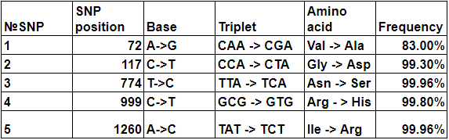

Also there was two rare mutations at positions 307 and 1458 which can be seen in next table:

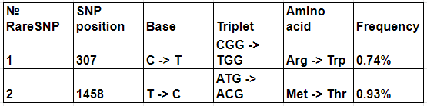

**Discussion.** We identified mutations in regions of Hemagglutinin and based on the data obtained, we assume that all of the mutations could affect the fact that the flu vaccine did not work, one of which is located in the epitope C. Conducting a deeper analysis to obtain and compare found mutations to the mutations of three reference sequences, we were able to suggest their probable genesis.

1. Sano K., Ainai A., Suzuki T., Hasegawa H., The road to a more effective influenza vaccine: Up to date studies and future prospects, Vaccine, 35(40), 5388 - 5395, 2017
2. <https://www.ncbi.nlm.nih.gov/sra/?term=SRR1705851>
3. [Project log](https://github.com/bels4/Bioinf/blob/master/projects/project_2/Lab_journal.ipynb) (Jupyter Notebook)
4. Munoz E. T., Deem M. W. Epitope analysis for influenza vaccine design //Vaccine. – 2005. – Т. 23. – №. 9. – С. 1144-1148.